**Project: SKY NET**

**Interface Control Document for the Navigation Unit**

**Presented by**

**Participating Members:**

Andrew Thomas, Spenser Gorenflo, Connor Hill

Dhwanil Desai, Nisarg Shah, Miles Medearis, Yaya Nedd, Mariana Villalabeitia Arenas

Dylan Huss, Bria Booth, Suleyman Gokdemir

|  |  |  |
| --- | --- | --- |
| **Rev.** | **Date** | **Revision Notes** |
| 1 | 2021/09/30 | Initial Release |
| 2 | 2021/12/09 | Modified Reference Document Names |

***Student Contribution:***

|  |
| --- |
| All students contributed equally to the development of this System Specification. |

***Table of Contents:***

Table of Contents

***1.*** ***Scope*** 4

***2.*** ***Applicable Documents*** 5

***3.*** ***Interface Specification Definition*** 5

# ***Scope***

****This preliminary component specification has been created for educational purposes. It does not capture the full component specifications required to develop the project.

* 1. Identification

The intent of this document is to provide an electrical and mechanical description of the interfaces related to the navigation system of the AUAV project. This document will contain enough information to plan the electrical and mechanical items needed to successfully connect electrically and fasten mechanically.

* 1. System Overview

The navigation system described in this document contains a set of sensors necessary to the flight operations of an AUAV. These sensors include IMU and GPS to detect the AUAV position. There is also onboard processor operations to interface with the AUAV flight computer. An electrical connection terminal strip is provided for ease of connection to the rest of the AUAV electrical system.

* 1. Document Overview

This document is intended to be used by the AUAV maintenance team to aid in simple reliable electrical and mechanical connection of the navigation system to the AUAV airframe. Within this ICD, Section 1 covers document identification, system overview, document overview, order of precedence, change authority, limitations and restrictions, and acronyms and glossary. Section 2 identifies the applicable documents. Section 3 identifies the specific interface definitions, physical characteristics and processing between the navigation system and the flight computer and the power and propulsion system within the AUAV. Section 4 contains notes and section 5 contains the appendixes. A section not relevant to a specific interface may be marked “Not applicable (N/A)”.

* 1. Order of Precedence

In the event of a conflict between the content of this ICD and the references cited, the requirements will always take precedence. Nothing in this ICD supersedes applicable laws and regulations unless a specific exemption has been obtained.

* 1. Change Authority

The approval authority for the ICD is the Area Code Diversity Collective Configuration Control Board (CCB). Changes to this ICD must be coordinated with the SECURE IPT and both sides of the interface and approved by the CCB.

# ***Applicable Documents***

* 1. Government Documents

MIL-STD-3046 (DI-SESS-81876) Interface Control Document (ICD) 28 February 2013

* 1. Non-Government Documents

Project SKYNET Design Dossier Rev 3 December 09, 2021

Project SKYNET System Specification Rev 3 December 09, 2021

Project SKYNET Sub-System Specification Rev 3 December 09, 2021

Project SKYNET Component Specification Rev 3 December 09, 2021

# ***Interface Specification Definition***

* 1. Interface Overview

J1 is the main electrical terminal strip. This connection point contains all the electrical connections for input voltage, command data input and sensor data output. The only additional electrical connection is the GPS antenna connection which connects directly to the GPS receiver which is part of the navigation system.

* 1. Interface Descriptions
     1. J1 Terminal strip

The electrical terminal strip contains all the input voltage points to power the internal components of the navigation system. This input voltage point interfaces with the propulsion and power system on the AUAV. This terminal strip also contains all the command data input and the sensor data output lines that interface with the AUAV flight computer. The terminal strip screws are #2 Philips.

* + 1. GPS RF Antenna Input

The GPS receiver component of the navigation system contains a single RF antenna port that interfaces with the GPS antenna that will be mounted elsewhere in the AUAV. The connector type is SMA.

* 1. Interface Data
     1. J1 electrical interface data

|  |  |
| --- | --- |
| Pin | Description |
| J1-1 | 12 VDC input |
| J1-2 | 12 VDC return |
| J1-3 | Data from flight computer |
| J1-4 | Sensor data to flight computer |
| J1-5 | Data Sync + |
| J1-6 | Data Sync - |
| J1-7 | Spare |
| J1-8 | Spare |
| J1-9 | Spare |
| J1-10 | Spare |
| J1-11 | Spare |
| J1-12 | Spare |
| J1-13 | Spare |
| J1-14 | Spare |
| J1-15 | Spare |
| J1-16 | Spare |

* + 1. Interconnect Drawing

**RF**

**J1**

Figure 1 Interconnect Drawing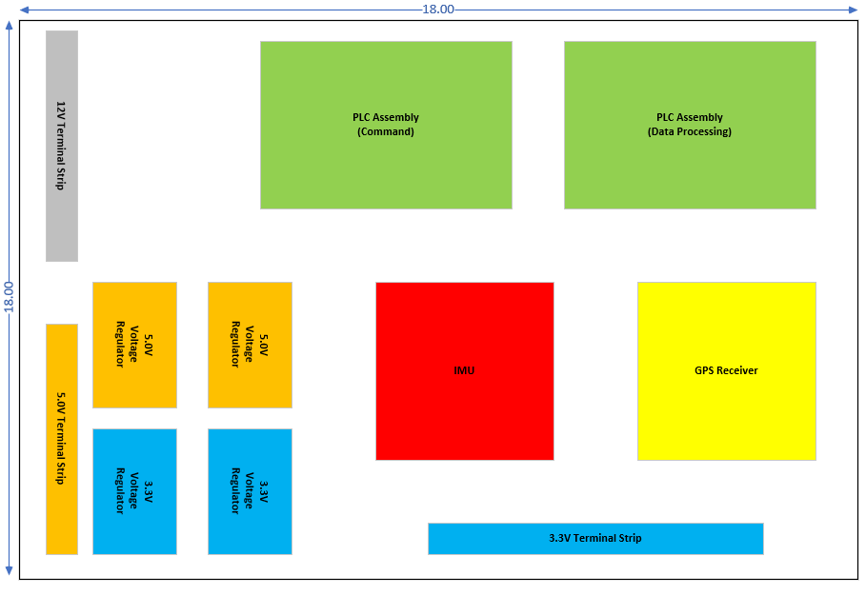

* + 1. Structural/Mechanical

The navigation system is comprised of individual components and electrical wiring that connects each of these items together. All these components are mounted to an aluminum mounting plate that also has hold down clamps to contain the wiring harnesses. This aluminum plate is shock mounted to survive the AUAV flight environment. The corners of the aluminum mounting plate are drilled to accept 0.50” [12.70 mm] aviation grade bolts. The mounting hole pattern is shown in the figure below:

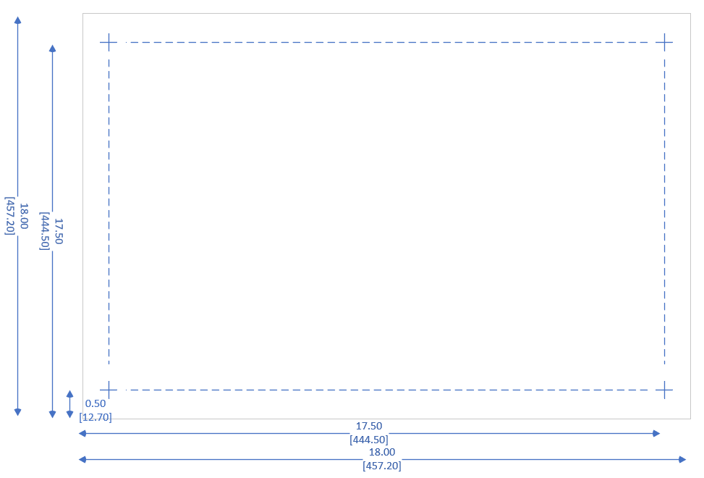

Figure 2 Mechanical Mounting Diagram

* + 1. Installation and Removal
       1. Installation

The installation process shall begin with the physical mounting of the mounting plate into the AUAV airframe. When that is complete, torque the mounting bolts to 480 – 690 inch/lbs. The next step is to connect the RF antenna wiring to the GPS receiver. Torque the SMA connector to 3 – 5 inch/lbs. Loosen the screws on the J1 terminal strip and attach the appropriate wires according to the wiring table shown in section 3.3.1 above.

* + - 1. Removal

The removal process is basically a reverse of the installation process from above. Loosen and remove the GPS antenna cable from the GPS receiver. Loosen the screws from the J1 terminal strip just enough to remove the wires. Move the cable harness to the side. Loosen and remove the four mounting bolts from the aluminum plate. Remove the navigation assembly from the AUAV airframe. Tighten the J1 terminal strip screws to ensure that they are not lost.

* + - 1. Hardware Envelope

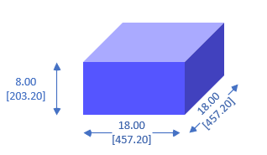

Figure 3 Hardware Envelope

The figure above shows the necessary hardware envelope to mount the navigation system inside the AUAV. This envelope includes all the required space to incorporate the individual COTS manufacturers recommended clearances. Additional cooling is not required for this system as the navigation system bay already has on-board cooling provided. This navigation system generates little heat and a very low airflow will generate enough cooling for proper operation.

* + 1. Weight

The overall weight of the navigation system shall not exceed 100lbs.

* + 1. Center of Gravity

TBSL

* + 1. Connectivity

The table below shows the mating connector types and manufacturer numbers that can be used to connect to the navigation system. The part numbers listed are representative parts. Other equivalent parts are acceptable, and they will accomplish the same function.

|  |  |  |  |
| --- | --- | --- | --- |
| Connection | Type | Manufacturer | Part Number |
| J1 Terminal strip (All) | Terminal | 3M | 94880 |
| GPS Antenna | SMA | Amphenol | 2903-6001 |

# ***Notes***

Not applicable (N/A)

# ***Appendixes***

* 1. Abbreviations and Acronyms

|  |  |
| --- | --- |
| Abbreviation | Description |
| AUAV | Autonomous Unmanned Aerial Vehicle |
| CCB | Configuration Control Board |
| COTS | Commercial Off the Shelf |
| GPS | Global Positioning System |
| ICD | Interface Control Document |
| Lbs | Pounds |
| SMA | Subminiature version A |
| VDC | Volts Direct Current |